Lab 8: CRUD Create Statements (8% of total grade)
Submission: Put your answers under each question, then submit this document as a PDF file to Blackboard (Assessments > Lab 8 - CRUD Create Statements).
Name your file: HTTP5126-L8-CREATE-LastNameFirstName.pdf, replace LastNameFirstName with your name as displayed in Blackboard.
Purpose: To practice CRUD functionality using SQL.
Requirements: For this assignment, you will use the provided Entity Relationship Diagrams to create tables and then use SQL to create data for some of those tables.
NOTE: Run your queries on your database to make sure desired results are achieved. Also import and execute your sql file to ensure it runs all your queries before submitting. For Part 1 and 2, each question should contain a single query.

Pre-Lab:
- Start your MySQL server and open phpMyAdmin.
- Create a database for this lab (eg. http5126_lab8). Set the collation as utf8_unicode_ci.
CREATE DATABASE http5126_lab8CHARACTER SET utf8mb4 COLLATE utf8mb4_unicode_ci;
- You will begin this lab with an empty database.

Part 1: [C]reate (2.5%)
Use SQL to create the tables defined by the Entity Relationship Diagrams(ERDs). The ERDs are located in the Appendix on the last page of this lab.
Ensure your CREATE TABLE query includes all the columns, data types, keys, and constraints defined by the ERD. In part 2, when inserting data, the id primary keys should be populated automatically where applicable.
- Create the customer table. [0.5%]
CREATE TABLE customer( email varchar(255) UNIQUE, name varchar(255) NOT NULL, PRIMARY KEY (email) );
- Create the supplier table. [0.5%]
CREATE TABLE supplier( supplier_id int AUTO_INCREMENT, name varchar(255) NOT NULL, location varchar(255) NOT NULL, PRIMARY KEY (supplier_id) );
- Create the order table. [0.5%]
CREATE TABLE orders ( order_id INT AUTO_INCREMENT, email VARCHAR(255), PRIMARY KEY (order_id), FOREIGN KEY (email) REFERENCES customer(email) );
- Create the product table. [0.5%]

- Create the order_product table. [0.5%]
Hint: Use the backtick character (`) to override keywords.

Part 2: Insert (2.5%)
Use SQL to insert data for each table. Use the data from part 2 of the Appendix.
- Insert the data for the customer table. [0.5%]
- Insert the data for the supplier table. [0.5%]
- Insert the data for the order table. [0.5%]
- Insert the data for the product table. [0.5%]
- Insert the data for the order_product table. [0.5%]

Part 3: More Inserts (3.0%)
For the following questions, you may either use subqueries, or assume that you will use select statements after inserting the data and just infer what the new IDs would be after the inserts to use in further inserts. Multiple queries will be required to satisfy each question.

- We just got a new Lenovo laptop in stock, and John wants to order one! Write a query that adds the Lenovo laptop, with a price of $1000, and comes from our supplier in Toronto. Then, add an order for this new product for John. [1.00%]

- We are expanding! Add our new supplier, “Audio Worldwide” in Ottawa, to our suppliers. Audio Worldwide offers us a new Sennheiser Headphones product, that is priced at $250. [1.00%]

- Our latest promotion is a huge hit, and has gotten us a few new sales. Alice has just ordered a Dell Laptop and a Samsung Smartphone in the same order. We also had a new customer, Bob, order a Canon Camera with the email bob@gmail.com. Write the queries that would create these orders in our system. [1.00%]

Appendix

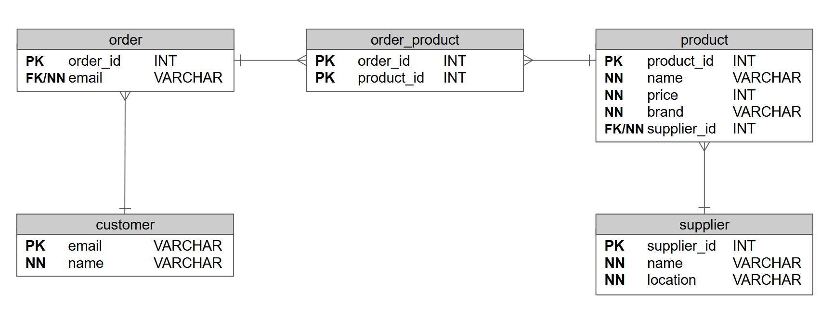
Part 1: Use the Entity Relationship Diagram below to complete Parts 1A to 1E

Part 2: Use the data in the tables below to populate your created tables from Part 1
